ONLINE-ONLY DATA SUPPLEMENT

**Btg2 mutation impairs renal function and blood pressure control in female rats.**

Matthew J. Hoffman 1,2, Akiko Takizawa 1,2, Eric S. Jensen 3,4, Rebecca Schilling 1,2, Michael Grzybowski 1,2, Aron M. Geurts 1,2, Melinda R. Dwinell 1,2

1Genomic Sciences and Precision Medicine Center, 2Department of Physiology, 3Biomedical Research Center, 4Department of Pediatrics, Medical College of Wisconsin, Milwaukee, Wisconsin

**EXPANDED METHODS:**

*Generation of Btg2 mutant rat strain on congenic SSBN13-Line 9E background* **-** The line 9E strain [SS.BN(D13Rat25-D13rs106935835)/Mcwi; RGD: 12802363] used in the current study was derived from line 9C [SS.BN(D13Rat124-D13Rat101)/Mcwi; RGD: 12802362] after backcrossing to parental SS/JrHsdMcwi (RGD: 61499). Following each backcross, the F1 progeny and F2 generations were intercrossed to isolate unique regions of the line 9C congenic interval using marker-assisted selection as previously described1. This method was used to generate line 9E and line 9F [SS.BN(D13Rat25-D13rs198199323)/Mcwi; RGD: 12802364] overlapping congenic strains used to isolate a 23kB QTL (line9BP4, QTL Bp398, RGD: 12879471) containing *Btg2* as a lone candidate gene2.

*Btg2* mutant rats were generated using transcription activator-like effector nuclease (TALEN) constructs specific for the rat *Btg2* gene designed to target exon 1 using the target sequence AGGTTTCCTCACCAGTCtcctgaggactcggggcTGCGTGAGCGAGCAGAGA (Fig. 1). The TALENs were assembled by Transposagen and validated by the Gene Editing Rat Resource Center at the Medical College of Wisconsin. mRNA encoding the *Btg2* TALEN constructs were diluted in microinjection buffer (1 mM Tris and 0.1 mmol/L EDTA, pH 7.4) at a concentration of 10 ng/μL and injected into one-cell line 9E rat embryos as described previously3. At 10-14 days of age, pups were ear-punched and DNA was extracted and screened for TALEN-induced mutations as described previously3. Among several mutant founders, one founder animal harboring a 44-bp deletion in exon 1 (RNO13:50,916,769-50,916,812; aaaccttgagtctctgctcgctcacgcagccccgagtcctcagg) was back-crossed to the parental line 9E strain and heterozygous animals from subsequent generations were intercrossed to generate homozygous mutant and wildtype littermates for phenotyping (Fig. 1). This strain is designated as SS.BN-(D13Rat25-rs106935835)-*Btg2em7Mcwi* (RGD ID: 10054305), hereafter referred to *Btg2-/-* or *Btg2* mutant and was used for all reported studies.

*Genetic Model Development***-** The rat *Btg2* gene contains 2 exons, 142 basepairs (bp) in exon1 and 335 bp in exon2, separated by a 1241 bp intron. The TALEN targeted bp positions 44 through 84 in exon 1 and resulted in a loss of 44 bp from positions 69 to 112 leaving 30 bp of unmodified sequence upstream of the 3’ exon 1 splice junction (Fig. 1). Donor and acceptor splice sites were assessed using NetGen24 and HSF5. Both tools confirmed that the wild type splice sites were not compromised in the mutated gene and no new predicted donor splice sites were introduced as a result of gene editing. The wild type protein has a length of 158 AA. The mutated gene sequence introduces a frameshift with a predicted premature stop codon following 24 AA and L24Q is the only predicted AA substitution in this truncated peptide (Fig. 1) (ExPasy6). In the wildtype protein AA10-26 represent an alpha helix (PDB ID:3DJU7 and AA positions 1-38 have been shown to interact with HoxB98. The 3’ end of the first exon also contributes to a LxxLL motif which has been shown to assist in estrogen receptor alpha mediated transcriptional regulation9. The L24Q AA substitution in the mutated gene’s predicted protein is located within the LxxLL motif (Fig 1).

*Fluorescent genotyping for litter zygosity assessment* - A portion of an ear from each rat pup was collected and processed for DNA extraction. The DNA samples were genotyped with fluorescent M13-labeled primers. In brief, genomic DNA (25 ng) was amplified by PCR in a 6-μl reaction containing 150 nmol/l of primer-dye conjugate, 10 nmol/l Trizma base, 1.5 mmol/l MgCl2, 50 mmol/l KCl (pH 8.3), 200 μmol/l dNTP, and 1 U/μl Taq DNA polymerase. A “touchdown” PCR reaction was performed, samples were run on an ABI 377-96 DNA sequencer for 2 h, and data were analyzed with ABI Genescan and Genotyper1.

*Radiotelemetric blood pressure recording* **-** At 9 weeks of age, rats were anesthetized with inhaled isoflurane followed by implant of a blood pressure (BP) monitoring transmitter (PA-C40; Data Sciences International) surgically implanted subcutaneously at the rat’s left flank with catheter secured in abdominal aorta via the left femoral artery. The rats were administered the antibiotic enrofloxacin at 10mg/kg SC. The analgesic carprofen was given pre-operatively at 5mg/kg SC with post-operative ad libitum access to 0.1mg/ml in drinking water for up to 2 days. Following 3 days of recovery, 3 consecutive days of BP recordings by radio telemetry in conscious, freely moving rats were acquired at 500 Hz for 10 seconds every 2 minutes for 24 hours each day while the animals remained on the 0.4% NaCl diet (LS). The 24-hour BP recordings were averaged into single daily values. On the afternoon of the 3rd day, animal diets were changed to 8% NaCl diet (HS) and BP recordings continued daily for 21 days except for the 16th and 17th day of 8% NaCl while the rats were moved to metabolic cages for acclimation and 24-hour urine collection. The recording protocol ended in the afternoon on the 21st day of 8% NaCl and data from this day was not included in the 24-hour analysis. 6-8 animals were included in each group. The second day of LS recording was used for the control period for statistical analysis and figures.

To assess the mutant gene impact on diurnal variation, BP recordings were binned into 12-hour segments from 6am to 6pm and 6pm to 6am corresponding to the on/off room light cycle. The absolute value of the difference between adjacent 12-hour bin values was then normalized by dividing by the mean of the adjacent 12-hour bins. BP and heart rate data were analyzed across the same protocol indicated above.

*Renal Function Assessment -*After 16 days of 8% NaCl diet, the animals were placed in metabolic cages for overnight acclimation followed by a 24-hour urine collection. Urine samples were processed and analyzed by the MCW Department of Physiology Biochemistry Assay Core. Urine electrolytes were measured by flame photometry. Total protein was measured by Coomassie Plus-Better Bradford assay (Pierce, Rockford, IL), albumin was measured using albumin blue 580 dye using a fluorescence plate reader (FL600, Bio-Tek, Winooski, VT) and creatinine was measured using Jaffé reaction assay by autoanalyzer (ACE, Alfa Wassermann). At the end of the 21st day on 8% NaCl diet, animals were weighed and anesthetized with isoflurane. The kidneys and heart were then harvested, weighed, and stored in 10% formalin or frozen in liquid nitrogen and moved to -80C freezer for storage.

*Renal Histology -* Renal histological analysis was performed as described previously10,11. Briefly, after 21 days of 8% NaCl diet, the left kidney was harvested and fixed in 10% buffered formalin. Kidneys were bisected along coronal axis, paraffin embedded with an automated tissue processor, sectioned at 3uM, mounted on slides and stained with Masson’s Trichrome. The slides were scanned at 40x magnification and digitized using Hamamatsu NanoZoomer at 227nm/pixel (112k DPI) and assessed with NDP View software (Hamamatsu Photonics, Hamamatsu City, Japan). The digitized images were manually assessed for glomerular injury, tubulointerstitial fibrosis and cortical glomerular density. Glomerulosclerosis was scored on a scale of 0 (~0% injury) to 4 (>75% injury)12,13 and the data are presented as the mean score of at least 90 glomeruli per animal. At least 20 images of the outer medulla were taken at 20X magnification in the NDP View software and the images were analyzed for tubulointerstitial fibrosis using MetaMorph software (Molecular Devices, Sunnyvale, CA). Fibrosis was quantified by selecting for the blue hue of the fibrotic tissue and calculated as the percent of total outer medullary tissue area in the 20X image11. Trichrome stained slides were additionally assessed for glomeruli counts using Image J software (National Institutes of Health, USA) and normalized to cortical area using MetaMorph selection tools. The images used for cortex selection were 2.5x magnified images in TIFF format with a resolution of 7k DPI.

*Axial Skeletal Radiography (adult)* **-** Male and female rats aged 5 to 23 weeks were used for radiographic assessment of vertebral skeletal structure. The animals were imaged in sagittal and coronal (dorsal to ventral) planes using an Ultra Light 10040HF X-Ray unit with ST_VI Fujifilm imaging plate. Plates were digitized using Scan-X Digital System scanner and processed using the VetRay Vision 4.4.5 Vet XP/2000 X-Ray software. Vertebrae within the digital images were manually assessed (MH) under the supervision of a veterinarian (EJ).

*Axial Skeletal Staining (P1)* **-** Rat pups were collected at P1, euthanized with inhaled isoflurane and stored in 99% EtOH at room temperature overnight. The following day the contents of the thoracic and abdominal cavities were removed and the carcasses were stored in fresh 99% EtOH. To stain cartilage, pups were placed into an 80% EtOH solution containing 20% acetic acid and 0.013% Alcian Blue (SIGMA-Aldrich). Bone was stained by the addition of 0.005% Alizarian Red S (SIGMA-Aldrich) and immersion in 1% KOH solution for 1-2 days. Prior to imaging and analysis, the solution’s glycerol concentration was increased and KOH concentration decreased through daily solution changes until 80% glycerol was reached14. The skeletons were imaged and assessed for changes in cervical to sacral vertebral count and gross morphology.

*Quantitative Real-Time Polymerase Chain Reaction -*Total RNA from the renal cortex of 10 week old *Btg2+/+* and *Btg2-/-* male or female rats fed 0.4% NaCl or 8% NaCl diets for 7 days (n=3 per group) was isolated using the Trizol method. The isolated mRNA was synthesized to cDNA and transcript expression measured using SYBR green (Invitrogen, Carlsbad, CA) on a Quantstudio 6 Flex instrument (Applied BioSystems, Foster City, CA). Data were normalized to GAPDH and relative mRNA expression was determined using the ΔΔCt method as described previously15.

*Cell Cycle Quantitative Real-Time Polymerase Chain Reaction Array* **-** Cell cycle gene expression was examined using a rat cell cycle real time-2 profiler PCR array (PARN-020Z; Qiagen, Germantown, MD), according to the manufacturer’s protocol. Animals used in gene expression arrays were weaned to 0.4% NaCl diet and tissues were collected at 10 weeks of age following 7 days of 8% NaCl diet or remaining on 0.4% NaCl diet. Kidney cortex samples from 3 males and 3 females within each salt diet condition (0.4% NaCl, LS; or 8% NaCl, HS) and each genotype (*Btg2+/+*, WT; *Btg2-/-*, KO) were assessed. Individual samples were included in the assay with 4 samples run on each 384 well plate using Quantstudio 6 Flex instrument (Applied BioSystems, Foster City, CA). Data were normalized to *Ldha* (NM_017025), and relative mRNA expression from ΔΔCt method generated low salt to high salt comparisons in each genotype within each sex. Follow up comparisons were made between female *Btg2+/+* to male *Btg2+/+* data and female *Btg2-/-* to male *Btg2-/-* data using multiple T-test analysis. Discovery gene sets from multiple T-test analysis were determined using the Benjamini16 two-stage linear step-up procedure with a false discovery rate of Q = 5% (Graphpad Prism 8.3.0 software). The discovery gene sets were compared to one another to determine significant differentially expressed genes unique to *Btg2+/+* or *Btg2-/-* animals. The *Btg2-/-* specific gene set was assessed using Ingenuity Pathway Analysis software (Qiagen, Germantown, MD).

*Bioinformatic Functional Assessment* **-** The *Btg2-/-* specific gene set was assessed using Ingenuity Pathway Analysis17 (QIAGEN, Ingenuity Knowledge Base v51963813, 03/2020), Gene Set Enrichment Analysis18 (Broad Institute, MSigDB v7.0, 03/2020), and Multiple Ontology Enrichment Tool19 (RGD, 03/2020). Curated gene sets utilized in analysis originate from Ingenuity Knowledge Base, Molecular Signature DataBase, Gene Ontology, Kyoto Encyclopedia for Genes and Genomes, Reactome pathway database, Chemical and Genetic Pertubations, BIOCARTA, Pathway Interaction Database, and ImmuneSigDB.

*Statistical Analysis* **-** Statistical analyses were performed using Graphpad Prism 8.3.0 software. BP, heart rate and body weight data were analyzed using two-way ANOVA with Sidak post hoc analysis. Renal values and tissue weights were analyzed using unpaired Student T-test. Breeding zygosity was assessed using Chi-square test. Discovery gene sets from multiple T-test analysis were determined using the Benjamini16  two-stage linear step-up procedure with a false discovery rate of Q = 5%. P-values were considered significant at values less than 0.05. Data are presented as mean ± SEM.

---------------------------------------------------------------------------------------------------------------------------------------

**Figure and Table descriptions:**

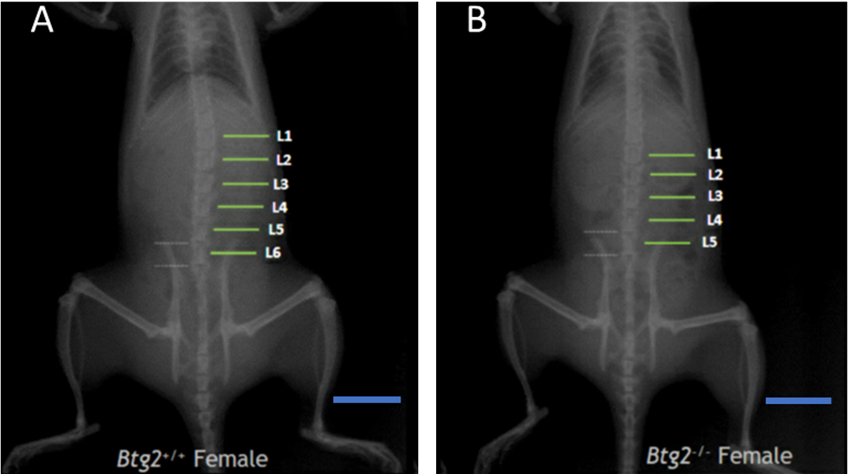

Figure S1. Radiographic example of axial skeletal differences in *Btg2-/-* compared to *Btg2+/+* female rats.

Radiographic images depict adult female *Btg2+/+* (A) and *Btg2-/-* (B) rats imaged in dorsal to ventral orientation. Green lines show location of lumbar vertebrae. White dashed lines display cranial and caudal L5 or L6 relationship with iliac crest. L, lumbar. Blue scale bar represents 2cm.

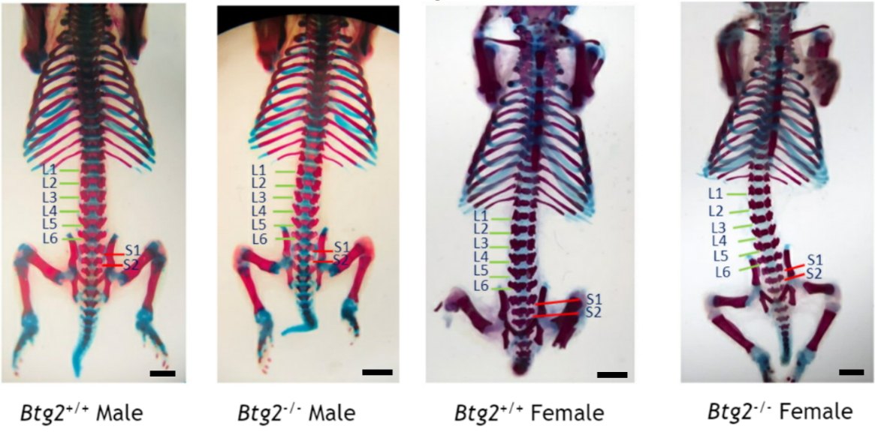

Figure S2. Histological example of axial skeletal differences in *Btg2-/-* compared to *Btg2+/+* male and female rats.

One day old male and female *Btg2-/-* and *Btg2+/+* pups were prepared and stained for histological assessment. Cartilage is stained blue and bone is stained red. Green lines show location of lumbar vertebrae. Red line displays sacral vertebrae relationship with ilium and acetabulum. L, lumbar vertebra; S, sacral vertebra. Black scale bar represents 3mm.

Table S1. Comparison of cell cycle gene expression from kidney cortex within female and male *Btg2+/+* and *Btg2-/-* rats after low or high salt diet.

Values represent gene expression differences between LS and HS conditions within male or female KO or WT tissue. N=3 in each condition. Directionality represents HS expression values direction compared to LS values. Significance was assessed by multiple T-test analysis using the Benjamini two-stage linear step-up procedure with an FDR of Q = 5%. KO, *Btg2-/-*; WT, *Btg2+/+*; LS, low salt diet; HS, 7 days of high salt diet.

**(tableS1.xlsx in accompanying file)**

Table S2. Btg2 and dietary salt effect on cell cycle gene expression in kidney cortex from female and male rats.

Values represent gene expression differences between female and male LS to HS conditions within KO or WT tissue. N=3 in each condition. Directionality represents male expression change direction compared to female values in WT or KO. Significance was assessed by multiple T test analysis using the Benjamini two-stage linear step-up procedure with an FDR of Q = 5%. KO, *Btg2-/-*; WT, *Btg2+/+*; LS, low salt diet; HS, 7 days of high salt diet.

**(tableS2.xlsx in accompanying file)**

Table S3. *Btg2-/-* gene set enrichment for toxicological function.

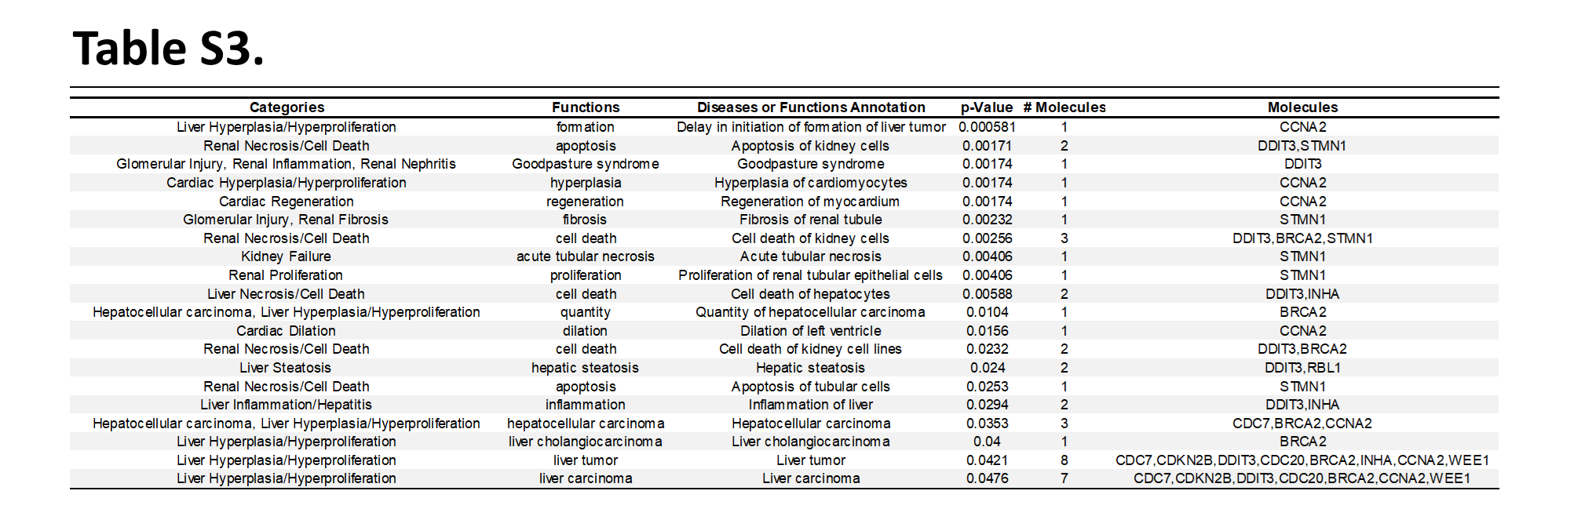

Functions included in table contain representation of unique Btg2-/- genes with p<0.05 as assessed using Ingenuity Pathway Analysis.

Table S4. *Btg2-/-* gene set assessment for upstream regulation.

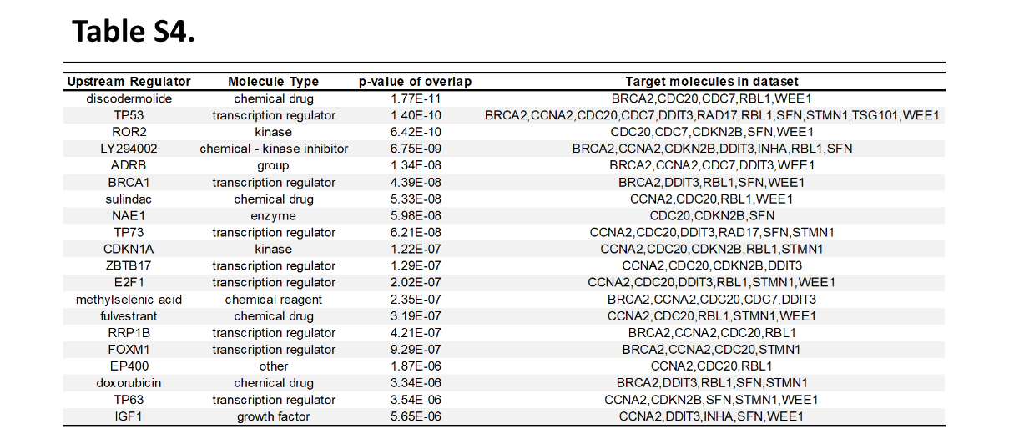

Top 20 molecules ranked by significance included in table contain representation of assessment using unique *Btg2-/-* genes from Ingenuity Pathway Analysis.

Table S5. *Btg2-/-* gene set enrichment for canonical pathways using IPA.

Top 5 pathways included in table generated using unique *Btg2-/-* genes assessed using Ingenuity Pathway Analysis.

Table S6. *Btg2-/-* gene set enrichment using disease and functional annotations.

Top 20 molecules ranked by significance included in table contain representation of assessment using unique *Btg2-/-* genes from Ingenuity Pathway Analysis.

Table S7. *Btg2-/-* gene set enrichment using curated databases using GSEA.

Top 10 enriched curated gene sets ranked by false discover rate using unique *Btg2-/-* genes within Gene Set Enrichment Analysis.

REFERENCES

1. Moreno C, Kaldunski ML, Wang T, Roman RJ, Greene AS, Lazar J, Jacob HJ and Cowley AW. Multiple blood pressure loci on rat chromosome 13 attenuate development of hypertension in the Dahl S hypertensive rat. *Physiol Genomics*. 2007;31:228-35.

2. Hoffman MJ, Flister MJ, Nunez L, Xiao B, Greene AS, Jacob HJ and Moreno C. Female-specific hypertension loci on rat chromosome 13. *Hypertension*. 2013;62:557-63.

3. Geurts AM, Cost GJ, Rémy S, Cui X, Tesson L, Usal C, Ménoret S, Jacob HJ, Anegon I and Buelow R. Generation of gene-specific mutated rats using zinc-finger nucleases. *Methods Mol Biol*. 2010;597:211-25.

4. Hebsgaard SM, Korning PG, Tolstrup N, Engelbrecht J, Rouze P and Brunak S. Splice site prediction in Arabidopsis thaliana pre-mRNA by combining local and global sequence information. *Nucleic Acids Res*. 1996;24:3439-52.

5. Desmet FO, Hamroun D, Lalande M, Collod-Beroud G, Claustres M and Beroud C. Human Splicing Finder: an online bioinformatics tool to predict splicing signals. *Nucleic Acids Res*. 2009;37:e67.

6. Artimo P, Jonnalagedda M, Arnold K, Baratin D, Csardi G, de Castro E, Duvaud S, Flegel V, Fortier A, Gasteiger E, Grosdidier A, Hernandez C, Ioannidis V, Kuznetsov D, Liechti R, Moretti S, Mostaguir K, Redaschi N, Rossier G, Xenarios I and Stockinger H. ExPASy: SIB bioinformatics resource portal. *Nucleic Acids Res*. 2012;40:W597-603.

7. Burley SK, Berman HM, Bhikadiya C, Bi C, Chen L, Di Costanzo L, Christie C, Dalenberg K, Duarte JM, Dutta S, Feng Z, Ghosh S, Goodsell DS, Green RK, Guranovic V, Guzenko D, Hudson BP, Kalro T, Liang Y, Lowe R, Namkoong H, Peisach E, Periskova I, Prlic A, Randle C, Rose A, Rose P, Sala R, Sekharan M, Shao C, Tan L, Tao YP, Valasatava Y, Voigt M, Westbrook J, Woo J, Yang H, Young J, Zhuravleva M and Zardecki C. RCSB Protein Data Bank: biological macromolecular structures enabling research and education in fundamental biology, biomedicine, biotechnology and energy. *Nucleic Acids Res*. 2019;47:D464-D474.

8. Prevot D, Voeltzel T, Birot AM, Morel AP, Rostan MC, Magaud JP and Corbo L. The leukemia-associated protein Btg1 and the p53-regulated protein Btg2 interact with the homeoprotein Hoxb9 and enhance its transcriptional activation. *J Biol Chem*. 2000;275:147-53.

9. Prevot D, Morel AP, Voeltzel T, Rostan MC, Rimokh R, Magaud JP and Corbo L. Relationships of the antiproliferative proteins BTG1 and BTG2 with CAF1, the human homolog of a component of the yeast CCR4 transcriptional complex: involvement in estrogen receptor alpha signaling pathway. *J Biol Chem*. 2001;276:9640-8.

10. Evans LC, Petrova G, Kurth T, Yang C, Bukowy JD, Mattson DL and Cowley AW, Jr. Increased Perfusion Pressure Drives Renal T-Cell Infiltration in the Dahl Salt-Sensitive Rat. *Hypertension*. 2017;70:543-551.

11. Prisco SZ, Prokop JW, Sarkis AB, Yeo NC, Hoffman MJ, Hansen CC, Jacob HJ, Flister MJ and Lazar J. Refined mapping of a hypertension susceptibility locus on rat chromosome 12. *Hypertension*. 2014;64:883-90.

12. Raij L, Azar S and Keane W. Mesangial immune injury, hypertension, and progressive glomerular damage in Dahl rats. *Kidney Int*. 1984;26:137-43.

13. Packard M, Saad Y, Gunning WT, Gupta S, Shapiro J and Garrett MR. Investigating the effect of genetic background on proteinuria and renal injury using two hypertensive strains. *Am J Physiol Renal Physiol*. 2009;296:F839-46.

14. Tijchon E, van Ingen Schenau D, van Opzeeland F, Tirone F, Hoogerbrugge PM, Van Leeuwen FN and Scheijen B. Targeted Deletion of Btg1 and Btg2 Results in Homeotic Transformation of the Axial Skeleton. *PLoS One*. 2015;10:e0131481.

15. Schmittgen TD and Livak KJ. Analyzing real-time PCR data by the comparative C(T) method. *Nat Protoc*. 2008;3:1101-8.

16. Benjamini Y, Krieger AM and Yekutieli D. Adaptive linear step-up procedures that control the false discovery rate. *Biometrika*. 2006;93:491-507.

17. Kramer A, Green J, Pollard J, Jr. and Tugendreich S. Causal analysis approaches in Ingenuity Pathway Analysis. *Bioinformatics*. 2014;30:523-30.

18. Subramanian A, Tamayo P, Mootha VK, Mukherjee S, Ebert BL, Gillette MA, Paulovich A, Pomeroy SL, Golub TR, Lander ES and Mesirov JP. Gene set enrichment analysis: a knowledge-based approach for interpreting genome-wide expression profiles. *Proc Natl Acad Sci U S A*. 2005;102:15545-50.

19. Smith JR, Hayman GT, Wang SJ, Laulederkind SJF, Hoffman MJ, Kaldunski ML, Tutaj M, Thota J, Nalabolu HS, Ellanki SLR, Tutaj MA, De Pons JL, Kwitek AE, Dwinell MR and Shimoyama ME. The Year of the Rat: The Rat Genome Database at 20: a multi-species knowledgebase and analysis platform. *Nucleic Acids Res*. 2020;48:D731-D742.